SWE40001 Software Engineering Project

Remote Guidance System

Software Requirements Specification

**Table 1. Document Change Control**

|  |  |  |  |
| --- | --- | --- | --- |
| **Version** | **Date** | **Authors** | **Summary of Changes** |
| 1.0 | 19/04/2018 | Tingcong Jimmy Li | Initial Draft |
| 1.2 | 08/05/2018 | Tingcong Jimmy Li | Updated based on feedback from quality assurance meeting. |
| 1.21 | 09/05/2018 | Liam Pan | Document Standards Review  Spelling and Grammar Review |
| 1.3.0 | 11/05/2018 | Tingcong Jimmy Li | Removed unnecessary product functions  Added new product functions  Update product perspective  Updated Product Block Diagram  Update use case diagram  Updated use case descriptions to reflect changes in product functions and use case diagram  Update user characteristics to reflect changes in user requirements  Update user interface to reflect changes in user requirements  Added References |
| 2.0 | 05/09/2018 | Tingcong Jimmy Li | Updated the following to reflect new requirements from the client:   1. Updated scope, perspective, product functions, feature tree, user characteristics, use case descriptions, to remove object recognition requirements and meat measuring. 2. Simplify user interaction from on-screen buttons to physical button clicks on devices. 3. Updated system interfaces, reflect changes in technologies used for this project |

**Table 2. Document Sign Off**

|  |  |  |
| --- | --- | --- |
| **Name (Position)** | **Signature** | **Date** |
| Dr. Tony Huang |  |  |
| Lyndon Prado |  |  |
| Tingcong Jimmy Li |  |  |
| Keagan Foster |  |  |
| Ayub Khan |  |  |
| Dineth Gunawardena |  |  |
| Kosala Edirisinghe |  |  |
| Krishna Adhikari |  |  |
| Migara Gunarathne |  |  |
| Shenal Nirushka |  |  |

# Table of Contents

Table of Contents 3

1. Introduction 5

1.1. Purpose 5

1.2. Project Scope 5

1.3. Definitions, acronyms, and abbreviations 5

2. Overall Description 6

2.1. Product Perspective 6

2.2. Product Functions 7

2.2.1. Send video feed 7

2.2.2. View video feed 7

2.2.3. Send hand gestures 7

2.2.4. Make sketch 7

2.2.5. Send sketch 7

2.2.6. View sketch 7

2.2.7. Dismiss Sketch 7

2.3. User Characteristics 8

2.4. Operating Environment 9

2.5. Constraint 9

2.6. Assumptions and Dependencies 9

3. Specific Requirements 9

3.1. External Interface Requirements 9

3.2. User Interfaces 9

3.3. Hardware Interfaces 11

3.4. System Interfaces 11

3.5. Communication Interfaces 11

3.6. Functional Requirements 11

3.7. Use Cases 12

3.7.1. Establish Communication 12

3.7.2. Send Video Feed 13

3.7.3. View Video Feed 13

3.7.4. Make Sketch 14

3.7.5. Send Sketch 14

3.7.6. Dismiss Sketch 15

3.7.7. Send Hand Gestures 15

3.8. Performance Requirements 16

4.References 16

# Introduction

## Purpose

The purpose of this document is to specify the requirements for the first working prototype of a portable Remote Guidance System (RGS). This document will provide the development team with a high level perspective of the system by illustrating its interfaces, constraints and the functional requirements. This document is intended to be a reference point for the development during the prototyping phase of the system.

## Project Scope

The Smart Glass Remote Guidance System will allow first-person interaction between instructors and operators. The system is used in combination with the Vuzix M100 Smart Glass for hands free communication between users.

Instructors can provide remote demonstrations using voice and hand gestures, which will be recorded from the first-person perspective of the instructor and live streamed onto the operator’s device. The operator simply needs to imitate the instructor’s hand gestures to complete a specific task. The operator can provide feedback to the instructor using hand sketches, which can be used for later analysis and discussion.

The system will include a server to facilitate wireless communication between the users.

## Definitions, acronyms, and abbreviations

|  |  |
| --- | --- |
| **Abbreviation** | **Description** |
| RGS | Remote Guidance System |
| Smartglass | Vuzix M100 Smart Glasses |
| Instructor | User whom are giving instructions |
| Operator | User whom are receiving instructions |
| Server | The communication processor between the devices, providing communication processing and wifi hotspot for devices |
| Device | Vuzix M100 Smart Glasses |
| RTMP | Real Time Messaging Protocol, real time messaging protocol for carrying audio, video and data cross networks |
| RTP | Real-Time Transport Protocol, used by android devices to transmit real-time data from/to a external network |
| TCP | Transmission Control Protocol |
| WLAN | Wireless Local Area Network |

## 

# Overall Description

## Product Perspective

The system consists of the device hardware, the device software and the server. The device software will be installed onto the Vuzix M100 Smart Glass (The device hardware). The device hardware will be used as the input and the output of the device software while the device’s software will be managing the communications to and from the server. The server will be the central processing unit of the system that will manage the communication between the devices as well as video processing, see Figure 1 - Block Diagram.

User inputs(controls) and video data from device hardware captured by the device’s camera, gesture sensor and microphone, its near-eye display and speaker will be used for video and audio output.

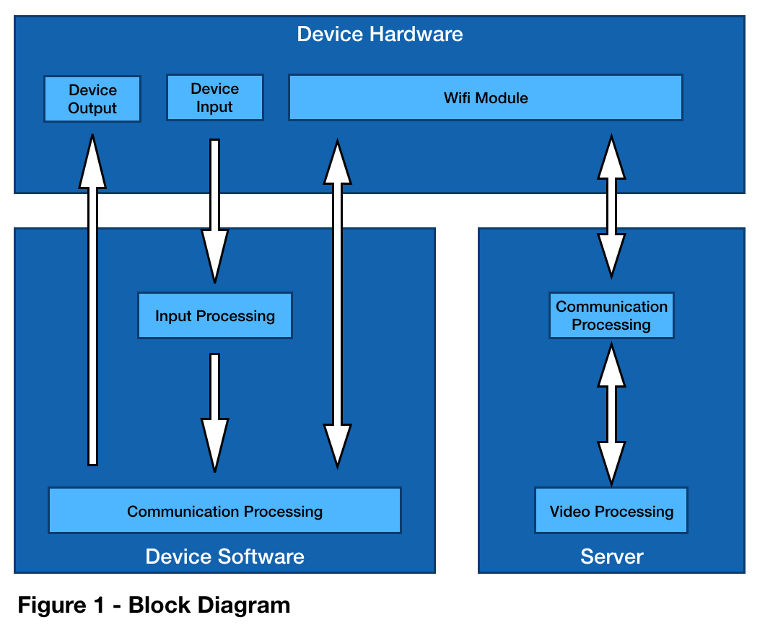

The video data streamed into the server will be processed base on the current user input(control). Processed video data will be streamed to both users to assure synchronisation between users. The server will be limited to two concurrent connections at any given time for the purpose of development and testing.

## Product Functions

### Send video feed

This function allows the user to send a video feed to the connected user, the video feed that is currently being viewed will be stopped. This function will be automatically triggered when the users open the application.

### View video feed

This function allows the user to view the video feed from the connected user. This function will be automatically triggered when the users open the application and when the video feed is available.

### Send hand gestures

This function allows “instructor” users to send hand gestures captured by the device’s camera to the connected user. This function will replace the “Send video feed” function, causing the hand gestures video feed to be sent in place of the ordinary video feed. This function will be automatically triggered for the instructor when the the application starts.

### Make sketch

This function allows “instructor” users to capture an image using the device’s camera and sketch onto the image using their finger.

### Send sketch

This function allows “instructor” users to send a sketch to the connected user. This function is only available after selecting the “Make sketch” function.

### View sketch

This function allows “operator” users to view the sketch received from the connected user. This function will be triggered when the “operator” receives sketch from the instructor.

### Dismiss Sketch

This function allows the “operator” users to dismiss a sketch after viewing.

### 

The following feature-tree diagram(Figure 2) shows the dependencies between major features and its sub-features that are required to implement the above functions.

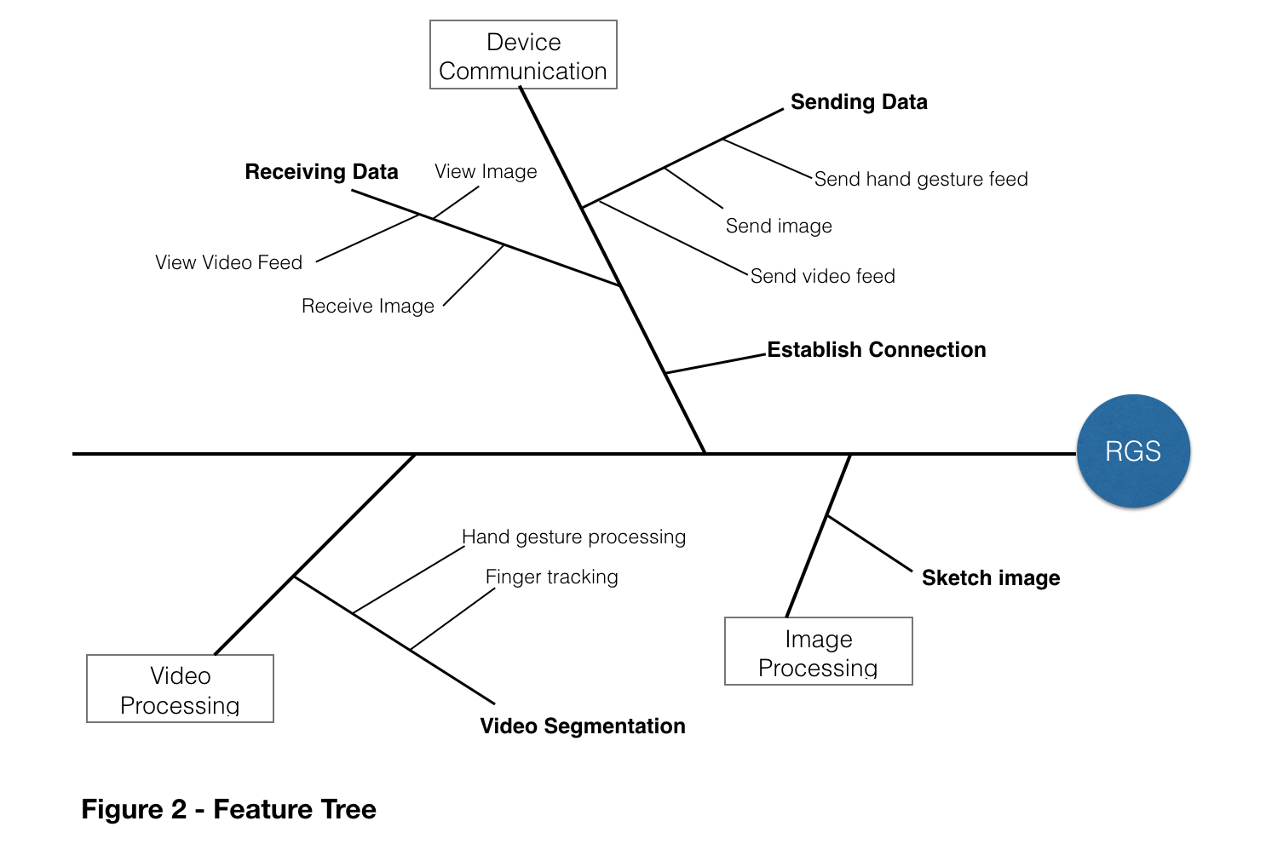

## User Characteristics

The system will support two types of users, instructors and operators. Functions are limited to each user type.

Instructor is able to send hand gestures, view video streams from the operator. The instructor can also capture images from the stream and make sketches using his/her finger(s). Video streamed will be displayed on his/her near-eye display as well as sketches when available. The operator will be able to dismiss a sketch by waving his/her hand.

Both users will be able to broadcast video streams to the other user, however only one user is allowed to broadcast video at any given time, and any existing broadcasting stream will be canceled when a new broadcast stream is initiated.

Considering the possibility that the operator may lack the training and knowledge of using the system. Furthermore, the operator is expected to be operating the system while performing other tasks, where user interactions between the operator and the system are reduced to a minimum. On the other hand, the instructor are most likely to be situated in a safe environment where active interactions with the system will not interfere with his/her safety. For these reasons, operator functions are designed to be passive and minimal while communications and interactions will most be initiated and conducted by the instructor.

The operator will not be able and are not required to initiate any functions from his/her device. Operator’s device will be automatically connected to the instructor as soon as a connection is available. The only action the operator is required to perform is to turn on the device.

The user interface should be easy to use without training. Interface control for the operator is reduced to a minimum, and the controls from the instructor will be handle using device buttons. The two devices will be configured to instructor and operator mode respectively.

## Operating Environment

RGS operates with the following environments

* Operating System: Android
* Programming Languages: Javascript, HTML, CSS
* Network: WLAN

## Constraint

The onboard computer of the smartglass currently operates with Android 4.0.4 Icecream Sandwich. Considering the hardware was released in 2009, the performance of the system may be impacted once it is updated to a higher version of Android. The development of the RGS will be using components and open source libraries that are compatible and available to Android 4.0.

The client has requested that the system should able to operate without internet connections. A local wifi hotspot will be used to facilitate communication between the two devices. The hotspot will also provide necessary messaging protocols such as RTMP and TCP to support video communication between the devices as well as to serve as the video processing unit for the system.

## Assumptions and Dependencies

The performance of the system is highly dependent on hardwares of both the server and smart glasses. The device was released in 2009 and operates on Android 4.0.4. The choice of libraries are dependent on their compatibilities with the operating system. We are assuming that the system performance will decrease when upgraded to higher version of Android.

# Specific Requirements

## External Interface Requirements

Both devices must be connected to the server through WIFI to enable cross device communication. Both devices will be connected to the same WLAN, and communication will be achieved using a combination of WebRTC, Socket IO and Node.js on the server.

## User Interfaces

The two devices will be configured to operate as Instructor and Operator respectively. When the users have turned on the device and the application, the application will attempt to establish a connection with the other device, see Figure 4.1.

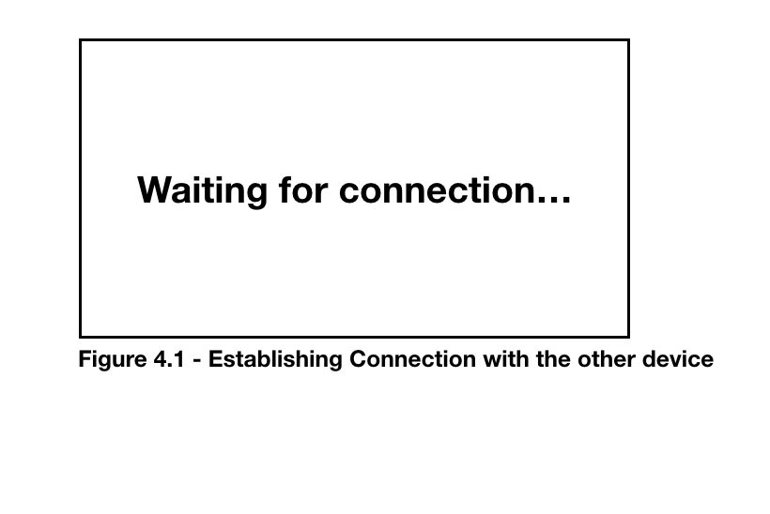

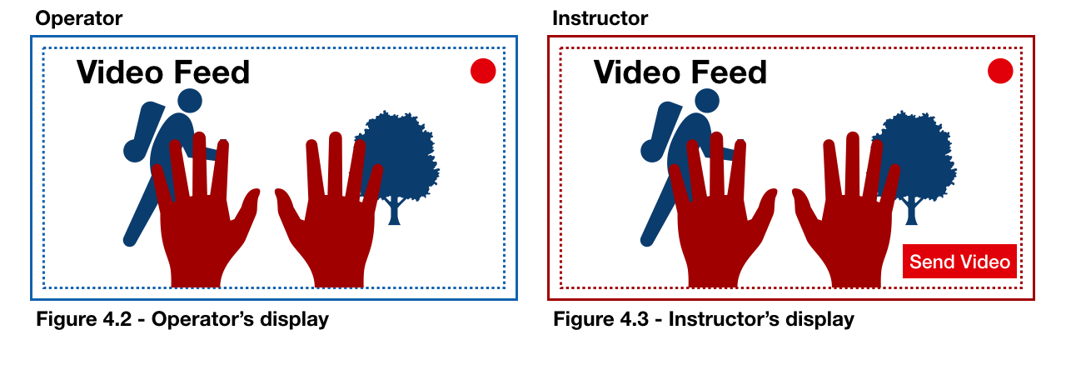

Once a connection has been established between the two devices. Operator’s device will begin capturing video data and broadcasted on the both devices, see Figure 4.2 and Figure 4.3. The video feed will be a combination of the operator’s captured video (blue) and the instructor’s hands (red), both users should be able to see the same video feed. A red dot will be shown on both user’s display to indicate communication is currently in progress.

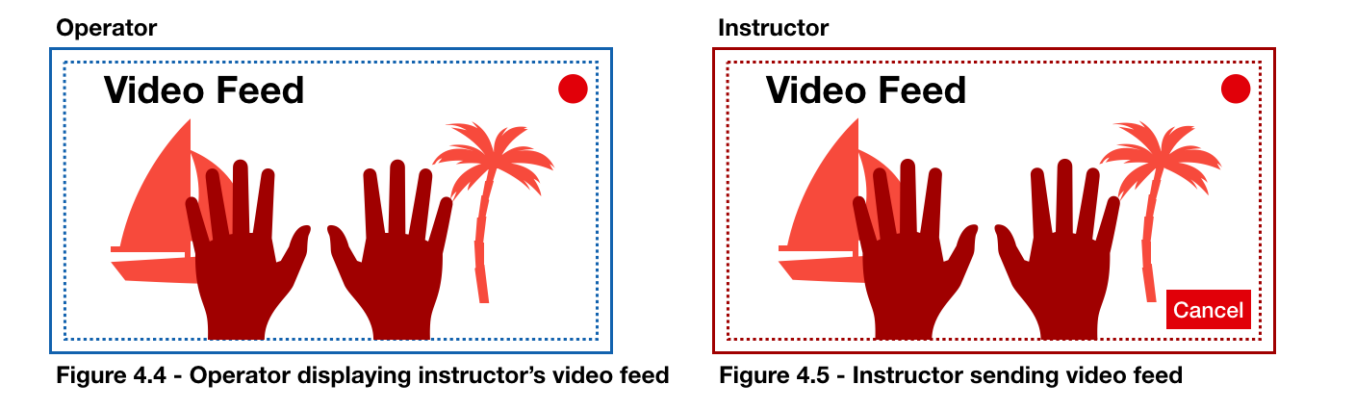

By click “send video” (see Figure 4.3), the instructor will be able to send his/her video feed (red) to the operator. The video feed will be displayed on both user’s devices, see Figure 4.4 and Figure 4.5. During demonstration, the buttons will be removed from the view and the actions will be achieved by a button on the glasses.

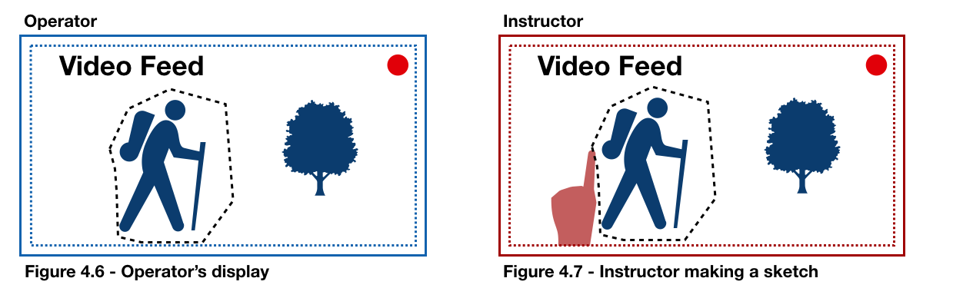

Instructor can capture a screenshot of the current video feed by pressing a button on the glasses. The captured image will be displayed on the instructor’s device. The instructor is then able to sketch on the image with his/her finger, see Figure 4.7. The instructor can send the sketch to the operator by clicking the same button on the glasses or a different button to discard to sketch.

The sketch made by the instructor will appear on the operator’s display. Once the operator has viewed the sketch. Operator can dismiss the sketch by pressing any button on the device, doing so will return to video feed mode. Instructor will return to video feed mode once the sketch has been sent or discarded.

## Hardware Interfaces

The Vuzix M100 Smart Glass is equipped with a series of sensors and a camera. The system will use its camera for video capturing. Video streams will be displayed on its near-eye display. Wireless communication between the Smart Glass and the server will be transmitted using its built-in wifi module. The server will be hosted locally on a laptop capable of sending and receiving wireless traffic from multiple devices as well as video processing.

## System Interfaces

Input and video data captured by the device’s software and hardware will be transmitted to the server. Video, audio and input(user commands) data will be processed on the server. Video processing methods include, hand tracking, video segmentation using OpenCV. The processed data will be transformed into image data and broadcasted(stream) to the devices. Data transfer between the devices and server will be utilising WebRTC and Socket.IO.

## Communication Interfaces

The devices will be communicating through a WLAN network hosted by the server. Communication and data transmission between the devices and server will be supported by WebRTC and Socket.IO. Video communications will be routed to the server, which will be broadcasted to the other device.

## Functional Requirements

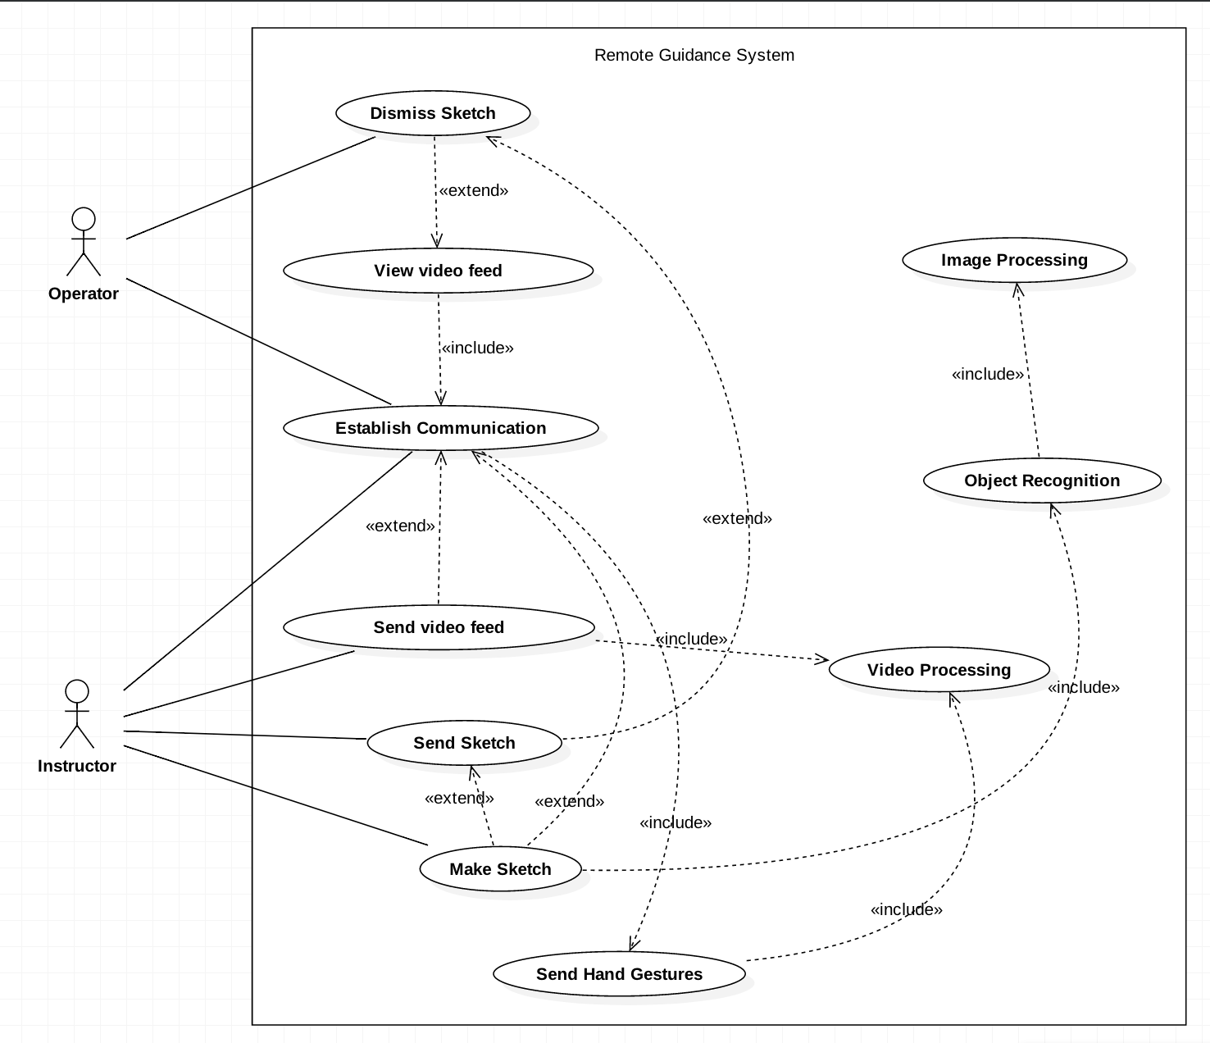

## Use Cases

### Establish Communication

|  |  |
| --- | --- |
| **Use case name** | Establish Communication |
| **Actor(s)** | Instructor, Operator |
| **Precondition(s)** | None |
| **Trigger** | User turns on the device, the system establish connection with the other device |
| **Procedure** | 1. User turns on the device 2. System attempts to establish a connection with the other device |
| **Extensions** | 2a. System displays a “loading…” message while waiting for a connection to be established  2b. System successfully established a connection with the other device |
| **Post Condition(s)** | Users can communicate  Connection between devices established |
| **Exception(s)** | Device cannot be powered off  Device is out of battery  Network not available  Application crashed |

### Send Video Feed

|  |  |
| --- | --- |
| **Use case name** | Send video feed |
| **Actor(s)** | Instructor, Operator |
| **Precondition(s)** | Device is switched on  Connection between devices established |
| **Trigger** | Connection Established between clients |
| **Procedure** | 1. System captures video feed from the client to server |
| **Extensions** | This function is automatically triggered on the both users’ devices once a connection has been established. |
| **Post Condition(s)** | Both users are shown the operator video feed with instructor’s hand overlayed |
| **Exception(s)** | Device is powered off  Application crashed  User has selected a role |

### View Video Feed

|  |  |
| --- | --- |
| **Use case name** | View video feed |
| **Actor(s)** | Instructor, Operator |
| **Precondition(s)** | Connection between devices established |
| **Trigger** | Triggered when the connection between instructor and operator has been established |
| **Procedure** | 1. System successfully establish connection between the two users 2. System captures video data from operator’s device to server 3. System captures video data from instructor’s device to server 4. System successfully processed the data 5. System broadcast processed video frame to both users |
| **Post Condition(s)** | Both users can see video data on their device’s display |
| **Exception(s)** | Device is powered off  Network crashed  Application crashed  User disconnected |

### Make Sketch

|  |  |
| --- | --- |
| **Use case name** | Make sketch |
| **Actor(s)** | Instructor |
| **Precondition(s)** | Connection between devices established  Video stream is active |
| **Trigger** | Instructor clicks a button on his/her glasses |
| **Procedure** | 1. System captures an image from the video stream 2. System displays the image on the instructor’s display 3. Instructor draws on the image using his/her finger in front of the camera 4. System captures the paths drawn by the instructor and overlays the path on top of the image 5. Instructor is shown the image with draw path |
| **Post Condition(s)** | Instructor is shown the sketch with paths he/she has drawn  Instructor can send the sketch  Instructor can discard the sketch |
| **Exception(s)** | Device is powered off  Network crashed  Connection failure  Application crashed |

### 

### Send Sketch

|  |  |
| --- | --- |
| **Use case name** | Send Sketch |
| **Actor(s)** | Instructor |
| **Precondition(s)** | Device is switched on  Instructor has created a sketch in “make sketch” function |
| **Trigger** | Instructor clicks the same button as 3.7.4 |
| **Procedure** | 1. System sends instructor’s sketch to the operator 2. System replaces the video stream on the operator’s display with the sketch |
| **Post Condition(s)** | Instructor’s display resumes to video stream capture by operator’s device  The sketch is shown on the operator’s display  Operator can choose to dismiss the image |
| **Exception(s)** | Device is powered off  Application crashed  Network crashed |

### Dismiss Sketch

|  |  |
| --- | --- |
| **Use case name** | Dismiss Sketch |
| **Actor(s)** | Operator |
| **Precondition(s)** | Device is switched on  Network is available  Operator has received the sketch |
| **Trigger** | Operator clicks any button on his/her glasses |
| **Procedure** | 1. System removes the sketch from the operator’s display |
| **Post Condition(s)** | Operator’s display resumes to video mode |
| **Exception(s)** | Device is powered off  Application crashed  Network crashed |

### Send Hand Gestures

|  |  |
| --- | --- |
| **Use case name** | Send hand gestures |
| **Actor(s)** | Instructor |
| **Precondition(s)** | User is connected with another user  Device is switched on  Network is available  Connection is established |
| **Trigger** | Once connection has been established between the two devices, this function will be triggered automatically |
| **Procedure** | 1. System captures video data from instructor’s device 2. System extracts instructor’s hands from the video 3. System overlays instructor’s hands on top of operator’s video stream 4. System streams the video(operator + instructor’s hand) to both users |
| **Post Condition(s)** | Both users can see the video of on their devices |
| **Exception(s)** | Device is powered off  User(s) disconnected  Application crashed  Network crashed |

## Performance Requirements

* The network delay between the clients and the server should be less than 100ms
* The time delay of hand gestures shown on the operator’s display and the current(real-time) hand gestures of the instructor should be less than 500ms
* The system should be able to to process minimum 10 frames per second from the camera when extracting hand gestures
* The server should be able to support 2 users at any given time

# 4.References

IEEE 830 - Software Requirements Specifics